FOR IMMEDIATE RELEASE

“CALABASH ELKS MAKE SOME VETERANS’ LIVES JUST A LITTLE BIT BRIGHTER”

“Honoring Our Senior Veterans for Their Service”

By Michael Trescak

The Veterans’ Affairs Committee (VAC) from the Calabash Elks lodge ~ 2679, hosted their 11th annual “Vet Day at the Lodge,” - a day of activities, brotherhood, and camaraderie which included; - A fishing trip to the Sunset Beach pier, - Lunch, and – a very special game of BINGO. The annual event is designed to recognize our senior veterans for their service and make their days “Just a Little Bit Brighter.”

The committee invited veterans from Summit Place Assisted Living in Little River, SC, -- Autumn Care Assisted Living facility in Shallotte, NC, and – the North Carolina State Veterans Retirement Home in Fayetteville, NC.

A group of World War II and Korean Conflict-era veterans, some wheelchair-bound, traveled from their respective assisted living facilities to the fishing pier in nearby Sunset beach, NC for a few hours of fishing and camaraderie where the members of the Elks’ committee supplied fishing poles, bait, and assistance to those who were hoping to catch the “Big One!” The group caught a total of 5 fish that day, but did not break last year’s record of 8 fish. The time on the pier was graciously donated by Becky & Mark Kaplan of Sunset Beach, NC. The entire group reconvened back at the lodge dining room for lunch cooked and served by committee members, followed by a very special game of BINGO, where -- the BINGO numbers are called until “Everyone” has had the opportunity to yell “BINGO,” and garner a prize. Both the veterans and the Elks’ committee members all had a rich, full day.

The mission of the Veteran’s Affairs Committee of the Benevolent Protective Order of Elks, Lodge ~ 2679, is to provide occasional funding, fraternal activities, and general support for our local Veterans, various Veteran’s Programs, and our Military located throughout the South-Eastern North Carolina area, as well as for our Retired and Wounded Warriors located in the Fort Bragg area of Fayetteville, NC, and Camp LeJeune in Jacksonville, NC. For more information about other ways our Elks Lodge supports our Veterans’ and Military Community, visit their web site at www.CalabashElks.Org and click on the [Veterans Affairs] TAB.

Key Words: “ELKs” – “Veterans” – “Fishing” – “Camaraderie”

Word Count: 356

Point of Contact: Michael Trescak, ELKs ~ 2679 Veteran’s Committee, Public Affairs Officer,
VAC@CalabashElks.Org (910-386-7759)

####

Photos Follow

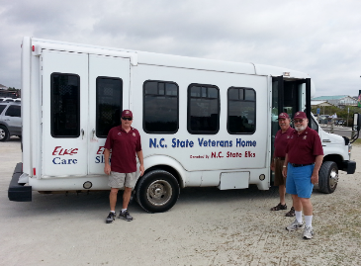
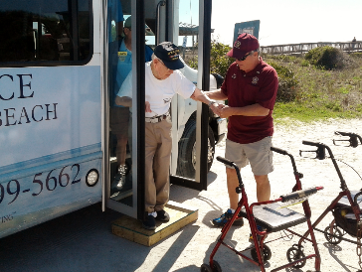
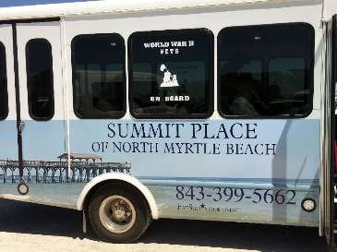
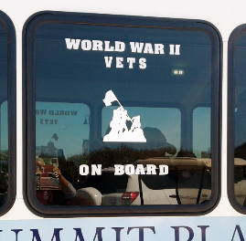
Pictured above – Members of the Calabash Elks Lodge’s Veteran’s Affairs Committee await the debarkation of the invited residents from the NC State Veterans Retirement Home in Fayetteville, NC for their “Fishing Adventure” at the Sunset Beach, NC fishing pier. The activities bus was donated by the NC State Elks Association.

Photo by Michael Trescak
Pictured above – John Corbett, Co-Chair of the Calabash Elks Lodge’s Veteran’s Affairs Committee, assists a 92-Year Old World War II Veteran getting off the Summit Place Assisted Living facility’s activities bus for his “Fishing Adventure” on the Sunset Beach, NC pier.

Photo by Michael Trescak
Summit Place Assisted Living Facility’s activity bus, which transports their residents to external events such as the Calabash Elks Lodge’s “Vet Day at the Lodge” hosted by the Veteran’s Affairs Committee, is pictured below. Please note the window decal which proudly announces the status of their precious passengers.

Photo by Michael Trescak

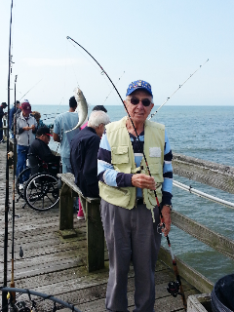
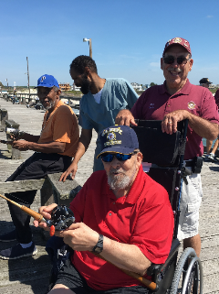
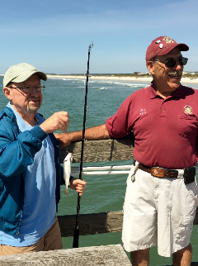
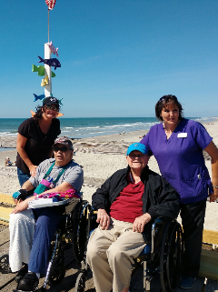
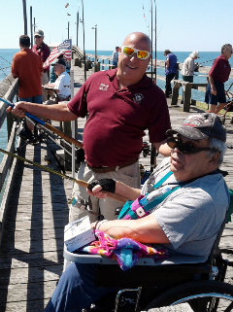
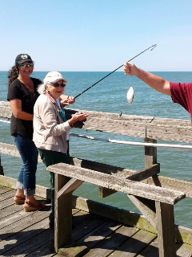
Pictured above – Our Senior Veterans on their well-deserved “Fishing Adventure”, accompanied by their “Fishing Guides” from the Calabash Elks Lodge’s Veteran’s Affairs Committee, enjoy a beautiful morning fishing off the Sunset Beach, NC Fishing Pier. Parking and Fishing Fees for the entire group were graciously donated by Becky & Mark Kaplan, owners of the pier. A total of 5 fish were caught that morning by our Senior Veteran Fishermen. Well Done!

Photos by Michael Trescak

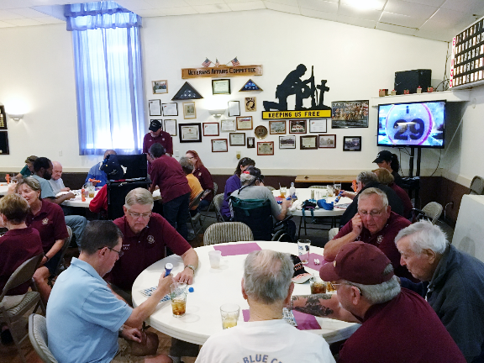
Pictured above – Our “Heroes of the Past,” Senior Veterans from local Assisted Living Facilities, - having spent their morning fishing off the Sunset Beach, NC pier, and - having had Lunch, - wrap up their “Day-at-the-Lodge” playing a Special Game of BINGO, where everyone Wins a Prize!
Photo by Robert “Shorty” Dennany

~ END ~

